Project Report: Student Academic Performance Predictor
Course: Fundamentals of AI and ML (Evaluated Course Project)
Student Name: Sunny Gupta
Registration Number: 25BAI11093
Institution: VIT Bhopal University

1. Introduction
The integration of Artificial Intelligence in education provides a transformative way to monitor student progress. This project focuses on building a Student Academic Performance Predictor using supervised learning. The objective is to forecast final examination grades based on behavioral, demographic, and historical academic data, allowing for early intervention by educators.

2. Problem Statement
Many students struggle to maintain consistent academic performance due to various underlying factors. Traditional grading systems only identify failure after it occurs. There is a need for a predictive system that can analyze variables like study time, attendance, and previous scores to provide a data-driven prediction of a student's final outcome.

3. Methodology and Algorithms
The project implements a supervised learning pipeline using two primary algorithms to compare their effectiveness:

3.1 Linear Regression
This model is used to predict a continuous numerical value (the actual grade percentage). It establishes a mathematical relationship between independent variables (e.g., hours studied) and the dependent variable (final score).
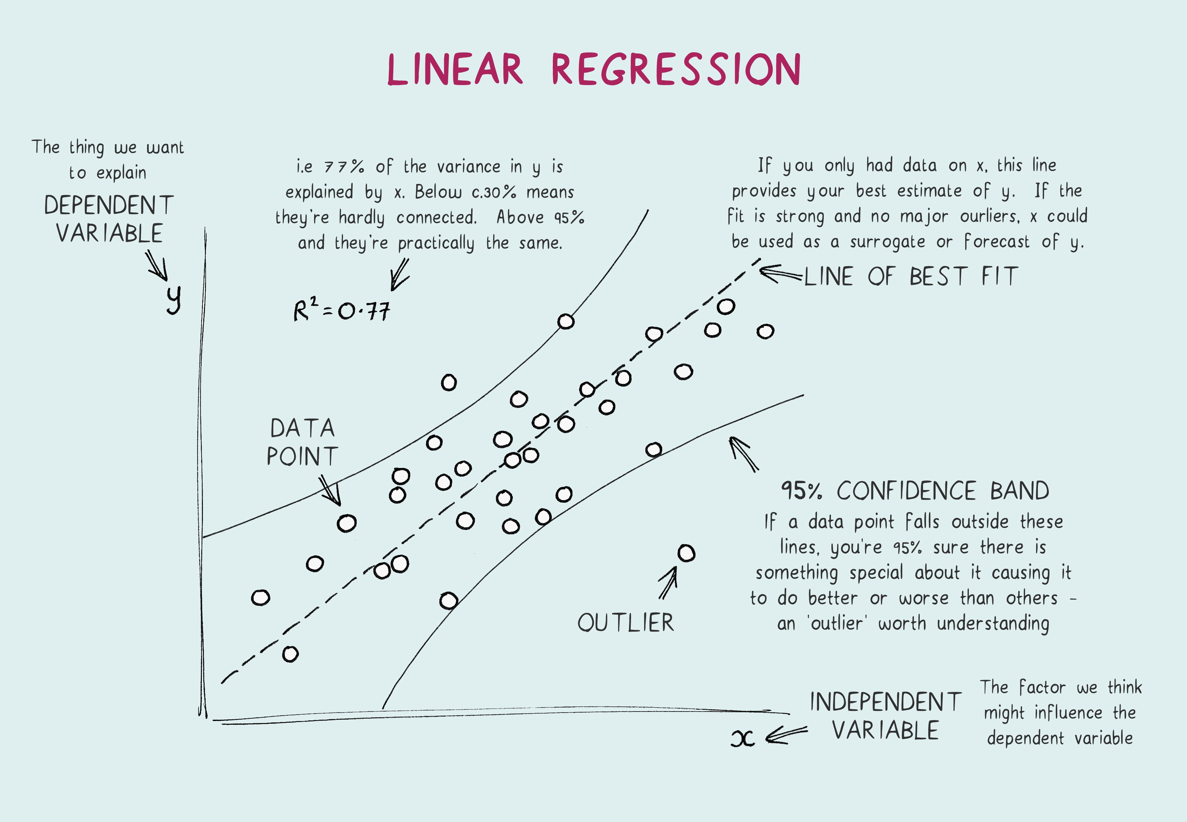
Shutterstock
Explore

3.2 Decision Tree Classifier
This model is used for categorical prediction (e.g., Pass/Fail or Grade Categories). It functions by splitting the data into branches based on feature importance, creating a readable flowchart of how a specific grade was reached.

4. Implementation Details
- Language: Python
- Libraries: Pandas (Data manipulation), Scikit-learn (Model training and evaluation), Matplotlib/Seaborn (Visualization).
- Dataset Features: * Input (X): Weekly study hours, Attendance %, Previous semester GPA, Parent education.
  - Output (Y): Predicted Final Grade.

5. Data Preprocessing
To ensure model accuracy, the following steps were taken:
- Data Cleaning: Handling null values and removing outliers.
- Feature Scaling: Normalizing data so that "Study Hours" and "Previous Scores" are evaluated on a comparable scale.
- Data Splitting: Dividing the dataset into 80% Training and 20% Testing to validate the model's performance on unseen data.

6. Conclusion and Future Scope
The project successfully demonstrates that supervised learning can effectively predict student outcomes. While the current model uses static data, future iterations could include real-time data from Learning Management Systems (LMS) and sentiment analysis of student feedback to improve prediction accuracy.

